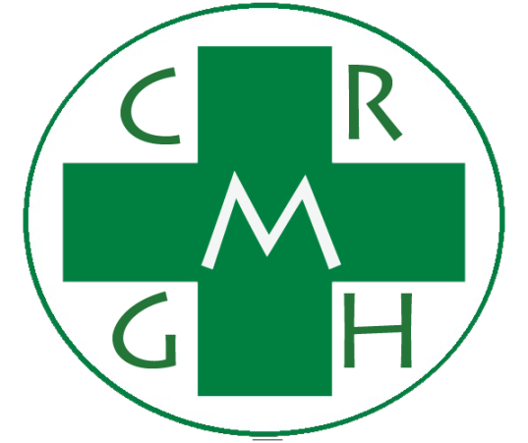

**Cruz-Rabe Maternity &**

**General Hospital Pharmaceutical Management System**

**Members:**

**Mark Kevin Navarro**

**Flordeliza Calanno**

**Cristine Ronario**

**Section:**

**IT112**

**Professor:**

**Mr. Allan Cotecson**

# Table of Contents

# Overview

## Scope

# References

# Definition and Acronyms

## Definition

## Acronyms

# Software Quality Assurance Plan

## Purpose

## Management

## Documentation

## Standards, practices, conventions, and metrics

## Reviews and audits

## Test

## Problem reporting and corrective action

## Tools, techniques, and methodologies

## Code control

## Media control

## Supplier control

## Records collection, maintenance, and retention

## 4.14 Risk management

**3. Definition and Acronyms**

**3.1 Definition:**

* Use Case Diagram **-** a software and system engineering term that describes how a user uses a system to accomplish a particular goal. A use case acts as a software modeling technique that defines the features to be implemented and the resolution of any errors that may be encountered.
* Test Case - is a set of conditions under which a tester will determine whether an application, software system or one of its features is working as it was originally established for it to do.
* Entity Relational Diagram - is a data model for describing the data or information aspects of a business domain or its process requirements, in an abstract way that lends itself to ultimately being implemented in a database such as a relational database. The main components of ER models are entities (things) and the relationships that can exist among them.
* Work Breakdown Structure – is a deliverable-oriented decomposition of a project into smaller components. A work breakdown structure element may be a product, data, service, or any combination thereof, A WBS also provides the necessary framework for detailed cost estimating and control along with providing guidance for schedule development and control.
* Local Web Server **-** is an information technology that processes requests via HTTP, the basic network protocol used to distribute information on the World Wide Web. The term can refer either to the entire computer system, an appliance, or specifically to the software that accepts and supervises the HTTP requests.

**3.2 Acronyms:**

**The following alphabetical contraction within the text appears of this standard:**

* CRPMS-PMS - Cruz-Rabe Maternity & General Hospital Pharmaceutical Management System
* UC – Use Case
* TC – Test Case
* WBS – Work Breakdown Structure
* ERD – Entity Relational Diagram
* LS – Local Server

**4.1 Purpose**

* The project aims to create an automated system of the CRPMS. The main purpose of the Project is to meet the all requirements of the Client.

**4.6 Test**

This section shall

a) Describe the practices and procedures to be followed for reporting, tracking, and resolving problems

Identified in both software items and the software development and maintenance process;

b) State the specific organizational responsibilities concerned with their implementation

**Test Items:**

* User Management Module
* Stocks Record Module
* Stocks Record Item Module
* About Medicine Module
* Stock Issue Form Module
* Stock Issue Item Module
* Return Slip Form Module
* Return Item Module

**Features that to be tested:**

* **User Management Module** 
  + User Interface
  + Functionality
  + Security
  + User Accessibility
* **Stocks Record Module (admin side)**
  + User Interface
  + Functionality
  + CRUD Function
* **Stocks Record Item Module**

**(admin side)**

* + User Interface
  + Functionality
  + CRUD Function
* **About Medicine Module (admin side)**
  + User Interface
  + Functionality
  + CRUD Function
* **Stock Issue Form (admin side)**
  + User Interface
  + Functionality
  + CRUD Function
* **Stock Issue Item Module (admin side)**
  + User Interface
  + Functionality
  + CRUD Function
* **Return Slip Form Module**

**(admin side and user side)**

* + User Interface
  + Functionality
  + CRUD Function
* **Return Item Module**

**(admin side and user side)**

* + User Interface
  + Functionality
  + CRUD Function

**4.8 Tools, techniques, and methodologies**

* **Scrum Methodology** - is part of the Agile movement. Agile is a response to the failure of the dominant software development project management paradigms (including waterfall) and borrows many principles from lean manufacturing. In 2001, 17 pioneers of similar methods met at the Snowbird Ski Resort in Utah and wrote the Agile Manifesto, a declaration of four values and twelve principles. These values and principles stand in stark contrast to the traditional Project Manager’s Body of Knowledge (PMBOK). The Agile Manifesto placed a new emphasis on communication and collaboration, functioning software, team self-organization, and the flexibility to adapt to emerging business realities.

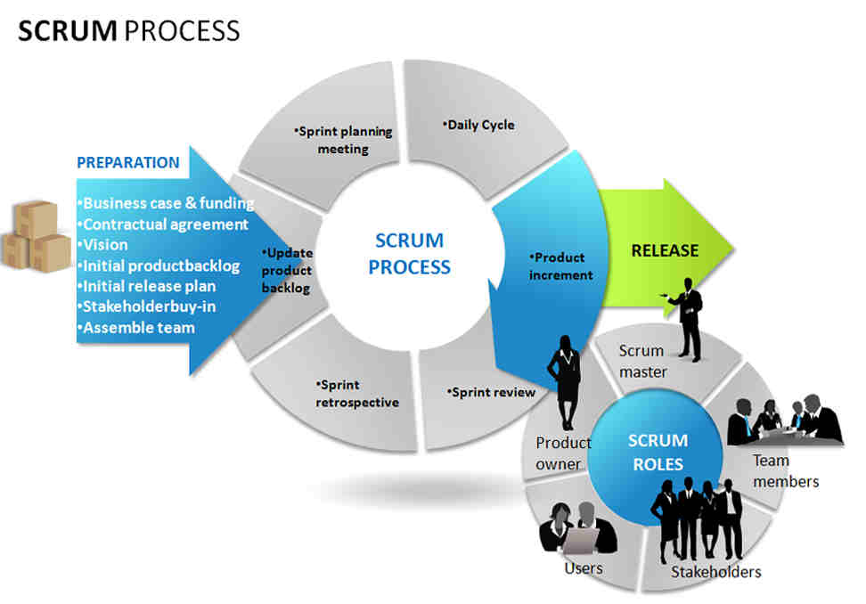

**Software Tools and Techniques:**

**• Programming Languages**

- PHP

- HTML5

- MySQL

**• Specific Software**

- Yii Framework

- Phpmyadmin

**• Web Server Application**

- Apache

- MySQL

**• Operating System**

- Windows 7 and Windows 8

**• Other Software/Applications**

- XAMPP

- Notepad++

- Sublime

- Browser (Mozilla Firefox, Google Chrome)

* **Hardware Environment**

- Desktop Computers/Laptop

**4.12 Records collection, maintenance, and retention**

This section shall identify the SQA documentation to be retained; shall state the methods and facilities to be used to

Assemble, safeguard, and maintain this documentation; and shall designate the retention period.